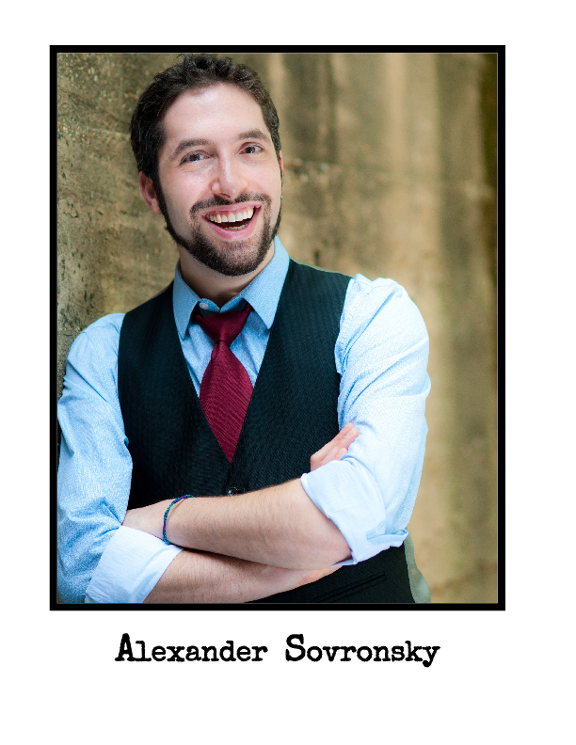
NINA ASHE
(MARCELLA, ROSENCRANTZ, PLAYER QUEEN, OSRIC)
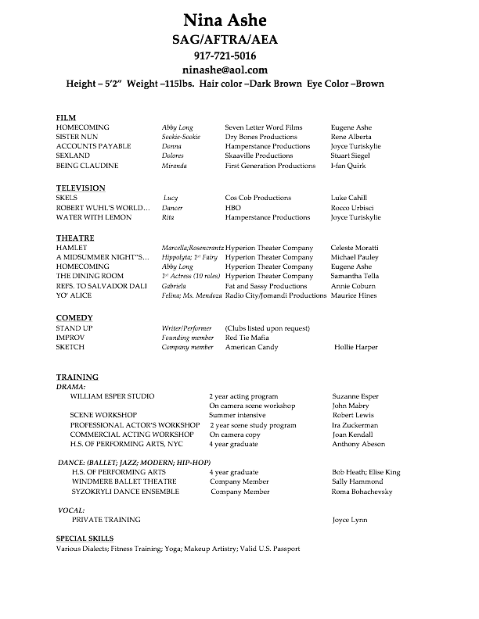

MICHAEL SAMUEL KAPLAN
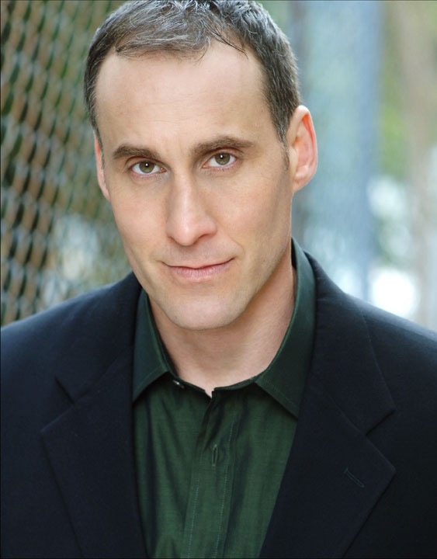
(POLONIUS)

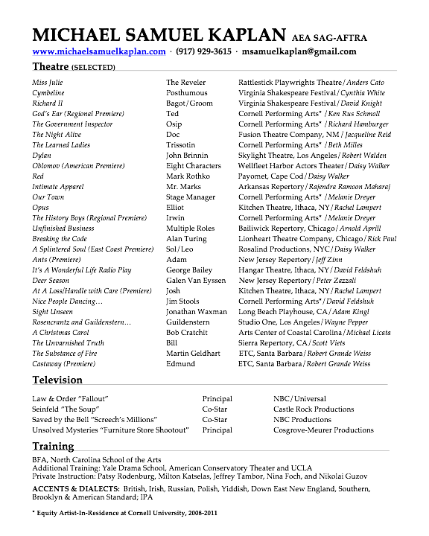

CELESTE MORATTI
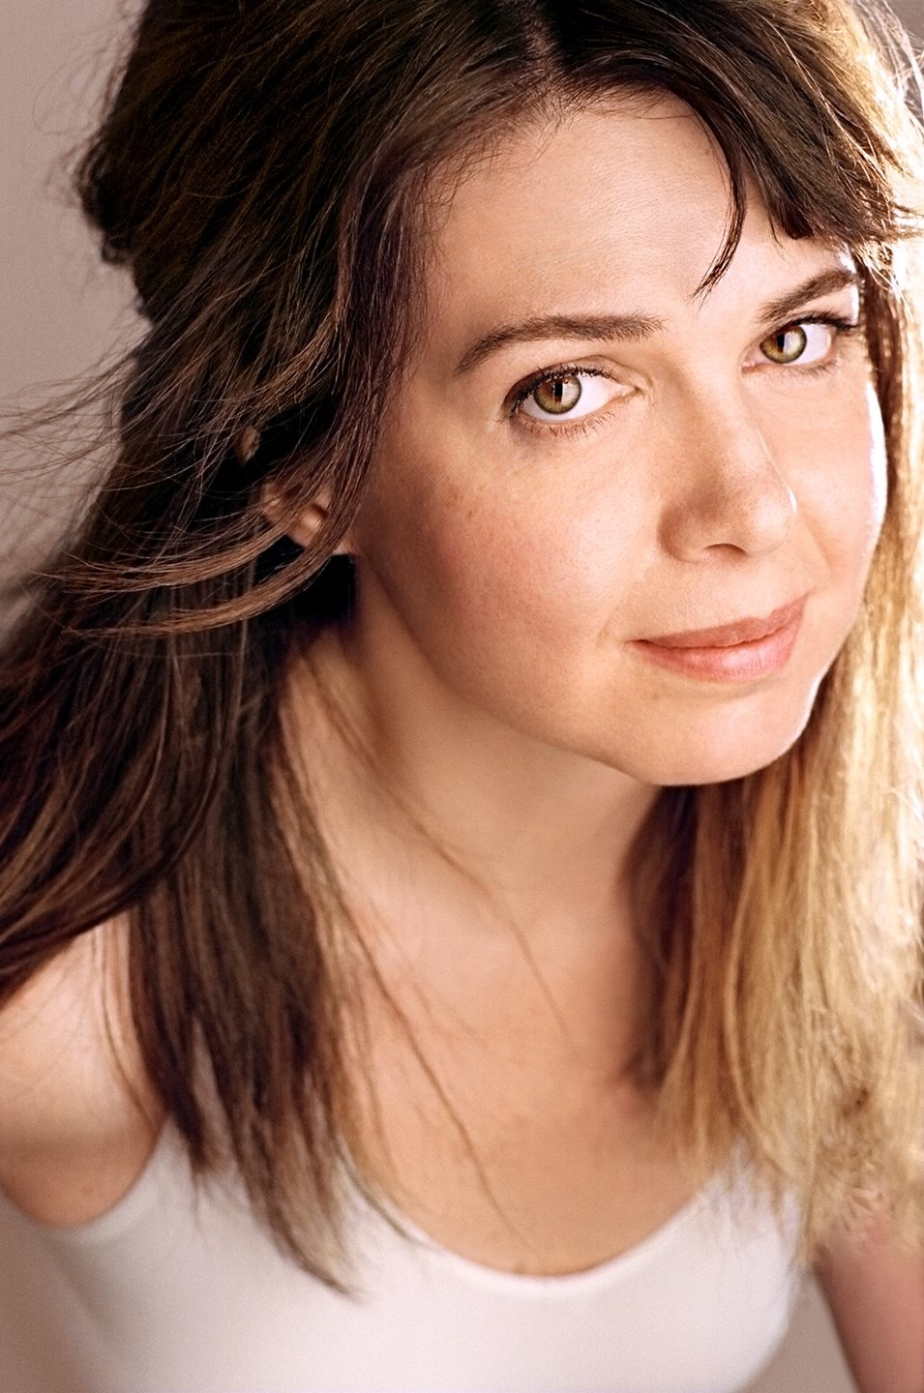
(DIRECTOR, PRODUCER, GERTRUDE)

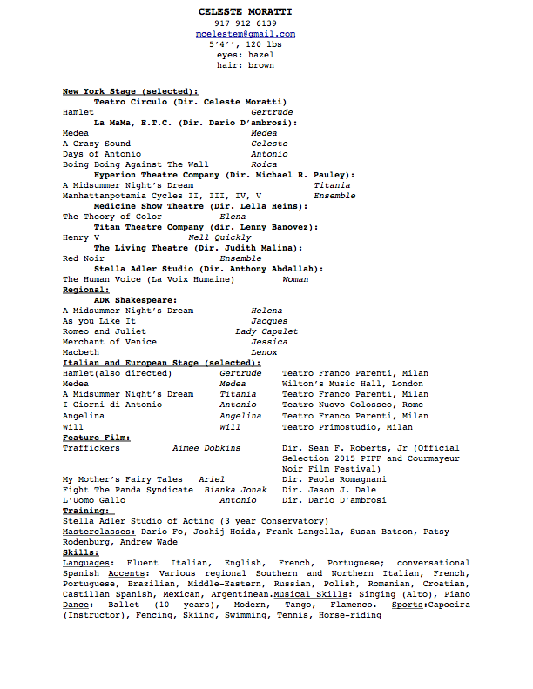

ALEXANDER SOVRONSKY
(HAMLET, FIGHT DIRECTOR)

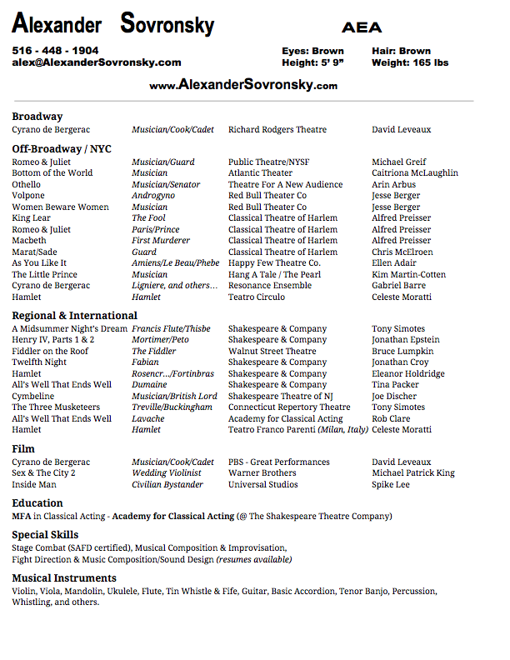

COLLIN MCCONNELL
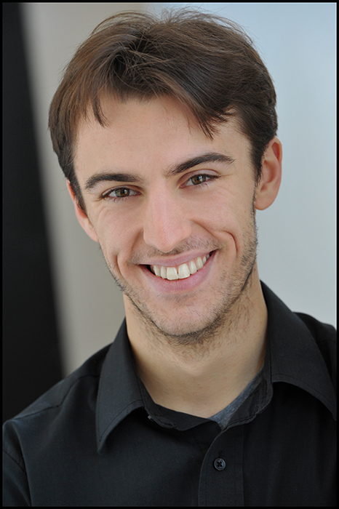
(HORATIO)
